Medium Term Plan – Art & Design

Year group | Topic title | Key question & concepts |  | Prior art skills | Future art skills
All | Colour Mixing Overview |  |  | Colour have focused on colour mixing as and when occasions arises. | Each year children will complete colour mixing in Sept (core skills) which will then be used within each art unit

Design brief |  | Vocabulary (Year Specific) |  | Linked Artist/Designer:
Children to create a “scrap book” page linked to relevant colour mixing skills. They will experience some of the main elements of Art (tone and colour) whilst learning about artists and other cultures |  | Yr 1: colour, primary, secondary, abstract  Yr 2: tone, light, dark, primary, secondary  Yr 3: Monochrome, primary, secondary, tone, hue, light, dark, tint, shade, pastel  Yr 4: Primary, secondary, tertiary, tint, shade, hue, pastel  Yr 5: Primary, secondary, tertiary, complementary, warm, cold, pastel, tint, shade, hue |  | Year 1 | Piet Mondrian – Primary Colours
 |  |  |  | Year 2 | Wassily Kandinsky - Tones
 |  |  |  | Year 3 | Pablo Picasso - Monochrome
 |  |  |  | Year 4 | Paul Signac – Tertiary Colours
 |  |  |  | Year 5 | Van Gogh – Warm / Cool / Complementary
 |  |  |  | Year 6

 | What children will learn | How they’ll learn it | Images | Resources
Year 1 | Primary Colours  Secondary Colours | Elicit knowledge of colours they know.  Explain that only 3 colours (Primary – this word should be on display) exist and from this we can make all other colours (with the support of black and white)  Introduced Piet Mondrian (have him up on a display). Give children facts about him (see flip) and explain his late movement was about primary colours only.  Set task: children to use square paper, rulers and paint to create their own “Mondrian” inspired piece. Focus here will be on painting in the same direction – choosing the right brush size. Explain to them to paint all the squares / rectangles first before outline. Focus on one c  colour at a time – give time limit.  Whilst drying – discuss secondary colour and how they are made – model how to mix colours together (equal amounts – do not need loads of paint). Ext: what would happen if we didn’t use equal amounts?  Children create a primary and secondary wheel.  Outline Mondrian picture – all work to be added into sketch books. | 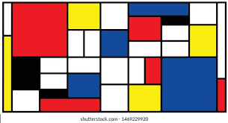 | Square Paper  Pencils  Rulers  Red. Blue, Yellow Paint (poster or powder)  Paintbrushes  Mixing Pallets  Water Pots
Year 2 | Shades and tints of colour | Quick re-cap on primary/secondary  Introduce tone. Discuss the terms ‘lighter’ and ‘darker’ and explain to children that this is known as the ‘tone’. How can you change the tone of a colour? The tone of a colour is determined by how light or dark it is. By adding black we can create a shade eg burgundy is a shade of red. Explain to children that tone can be changed by adding white or black paint. Always add dark to light.  Model in your sketch book (or paper) how to start with the primary colour and add a small amount each time to the colour and paint from primary to darker shade and then primary to lighter shade.  Stress the importance of only using a small amount of dark paint when mixing to avoid swamping the main colour.  Introduce Kandinsky.  Give details about him – have images of the paintings on flip for children to look at more closely – what do they notice? Can they see the different tones – how does the affect the atmosphere in the picture (scribe some response to be added to working wall).  Focus on the colours – can they spot the shades of red for example – which are lighter / darker?  Ask children to create a set of 3 concentric circles in the style of Kandinsky. | 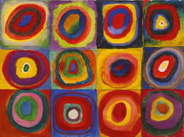 | White/black/red/yellow/blue poster paint  Paintbrushes.  Mixing palette  Water pots & rags  Sketch books
Year 3 | Varying tones of one colour (hue) | Monochrome (varying tones of one colour(hue))  Discuss the terms ‘lighter’ and ‘darker’ and explain to children that this is known as the ‘tone’. Slide 2 Re-cap: How can you change the tone of a colour? Add white=tint or pastel; add black=shade.  If an artwork is created through the use of only one colour plus black or white (i.e. different shades and tones e.g. red: pink, burgundy) we say it is ‘monochrome’.  Compare paintings – what do they like / dislike why?  Introduce task 1. Stress the importance of only using a small amount of white and dark paint when mixing to avoid swamping the main colour. Use jigsaw template (set class up with some children using yellow, some red, some blue and then compare their results).  Discuss Picasso.  Explain that he was inspired by travelling and death of a friend.  Children to practise their understanding of shades / tints and paint a template of cubists faces to create a “blue” image inspired by Picasso. Remind the children to only use a small amount of the white and especially black paint when mixing. | 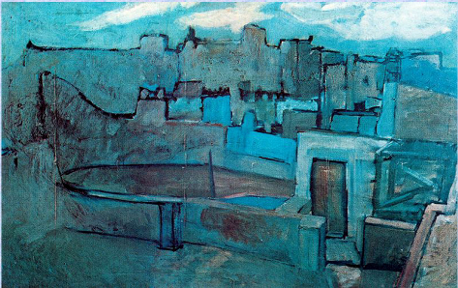 | White/black & Primary colour poster paint  Paintbrushes.  Mixing palette  Water pots & rags  jigsaw template  Cubism face templates
Year 4. | Tertiary Colours | Share colour wheel, remind children of primary and secondary colours and then introduce the term tertiary.  A tertiary colour is made up of more primary than secondary hence we have a yellowish orange and a reddish orange.  Introduce activity: Give out blank colour wheels – the aim is to create an accurate colour wheel. There should be as little difference as possible between the pupil’s work.  Stress the importance of only using a small amount of paint when mixing to avoid swamping the main colour.  Introduce Paul Signac and explain how his movement and work was inspired by colour to make the viewer have an in intense and bright colour experience. Model task. Focus on primary, then secondary, then tertiary.  Give children paper plates to mix colours (small amounts) – this could be put into sketch books. | 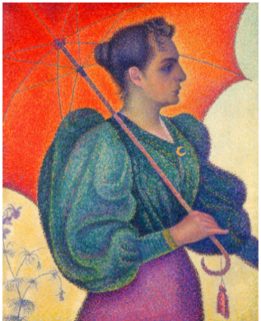 | primary poster paint  Paintbrushes.  Mixing palette  Water pots & rags  printed copy of colour wheel KS2 pupils.  Paper plates
Year 5 | Complementary Colours | Complementary colours and the Colour wheel  Recap the colour wheels. Answer the questions as they go through.  Focus on Warm & Cool Colours and then  Complementary colours. They enhance each other and effect the brain too. Complementary colors sit across from each other on the color wheel. How do they work? If you have a predominantly green color environment and then add a touch of red, the brain will make the green vibrate like crazy and the red will sing out.  Create your own complementary colour wheel. See model and demonstrate. Whilst waiting for it to dry to cut out – look at  Van Gogh focus.  Finish colour wheel and then create a “cool / warm complementary colour image in Van Gogh style. | 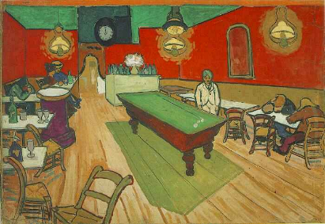 | primary poster paint  Paintbrushes.  Mixing palette  Water pots & rags  Ks2 pupils colourwheel– 2 per child.  Moon & Stars Print
Year 6 | Complementary and Harmonious Colours | Harmonious colours and the Colour wheel  Revise prior knowledge  Discuss ‘neutrals’ (you could model this on a paper to show how this works).  Re-cap – complementary colours. They enhance each other and affect the brain too. Complementary colours sit across from each other on the colour wheel. How do they work? If you have a predominantly green colour environment and then add a touch of red, the brain will make the green vibrate like crazy and the red will sing out.  Introduce harmonious colours and discuss.  Focus on Paul Klee – what do the like / dislike? Introduce task – model. (see mine). | 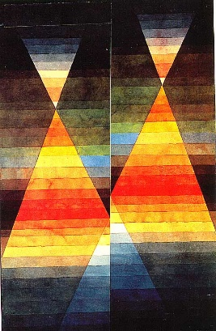 | primary poster paint  Paintbrushes.  Mixing palette  Water pots & rags  A3 sheets.  Copies of ‘Two Tents’.

