SCIENCE

We see a lot of crows, blackbirds and a few robins every now and then.
On my walk I saw: crows, pigeons, pheasants and I heard an owl hooting somewhere.

Common Raven Book
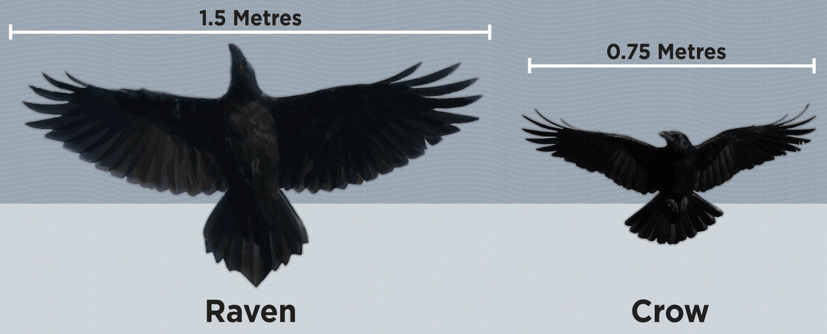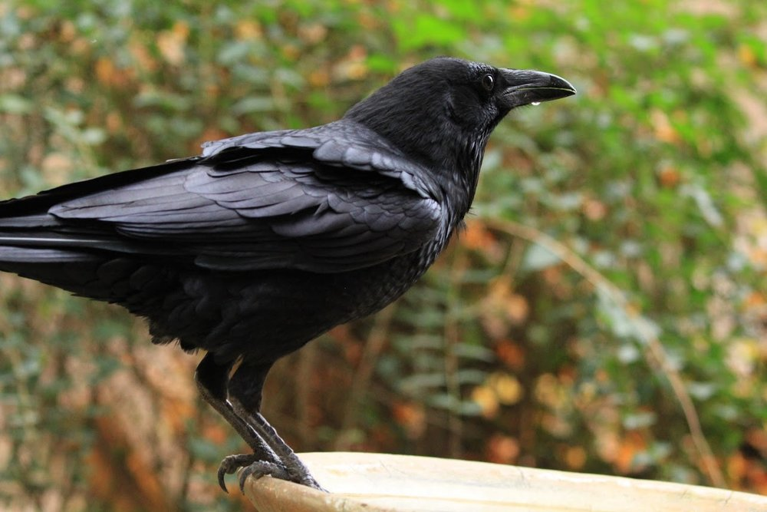
Fact File
Height - 22-27 inches
Weight - 24-53 oz
Plumage - Black Feathers
Beak - 2.2 - 3.3 inc
Eat - Omnivores - plants, insects, berries, grain,mice,scorpions, baby tortoises
Enemies - Owls Eagles, Martins
Lifespan - 10-15 years 40 in captivity
Sexual maturity - 2-3 years
Babies - Are born with no feathers, reliant on parents 1-3 months, live on groups called flocks
Females - Lay 3-7 eggs, hatch 20-25 days
Sound - Ravens produce 15-30 sounds and can imitate sounds

Ravens are medium sized, they are covered in black feathers and are quite common-. They are harmless birds. Most ravens are found in forest habitats across the northern hemisphere. These birds are seen a lot in the uk and you can see ravens all year round. Common ravens are obnivors but most of their diet is meat. They eat Arthropods, Seeds and Grain but they are more carnivores than crows. They also scavenge for carrion and garbage and they also prey on rodents and the eggs and nestlings of other birds. Ravens are amazing flyers and can do acrobatics especially during mating season, they are very playful and can catch sticks in the air, almost as good as a dog!
MYTH - Raven are mysterious and are associated with death and bad things.

