Birds around me

White heron 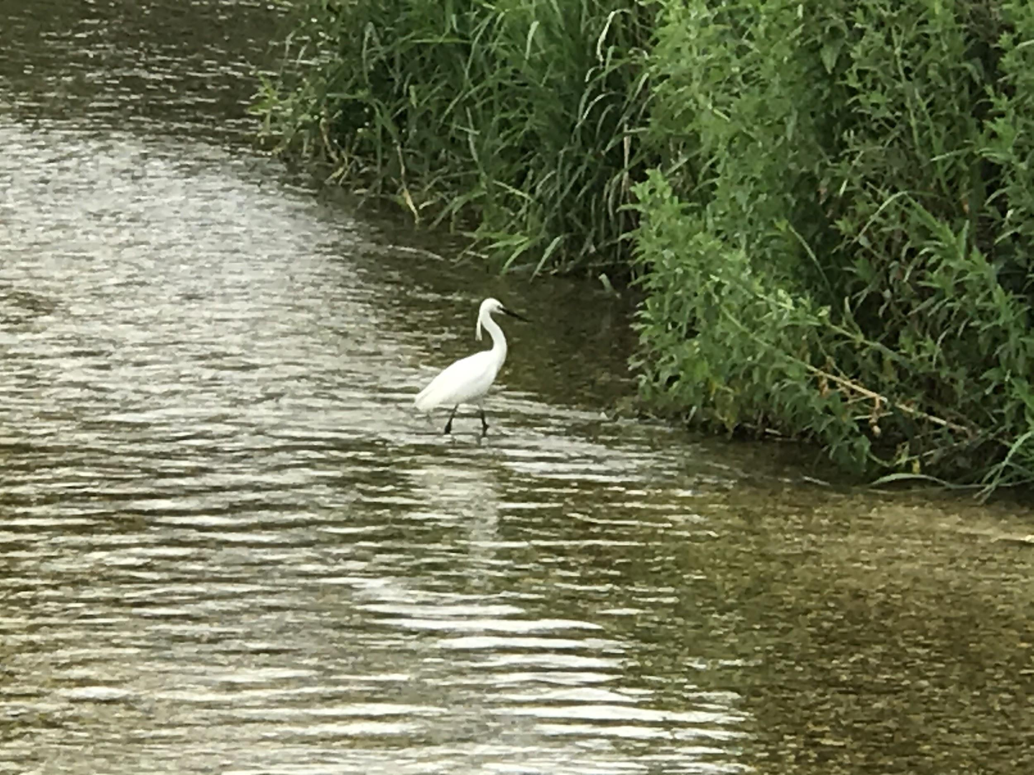

- White Herons can have a wingspan of 1.3m-1.7m as an adult.
- They can be found in Asia, Africa, The America’s and Southern Europe.

I found this White Heron in Houghton river.

Jackdaw
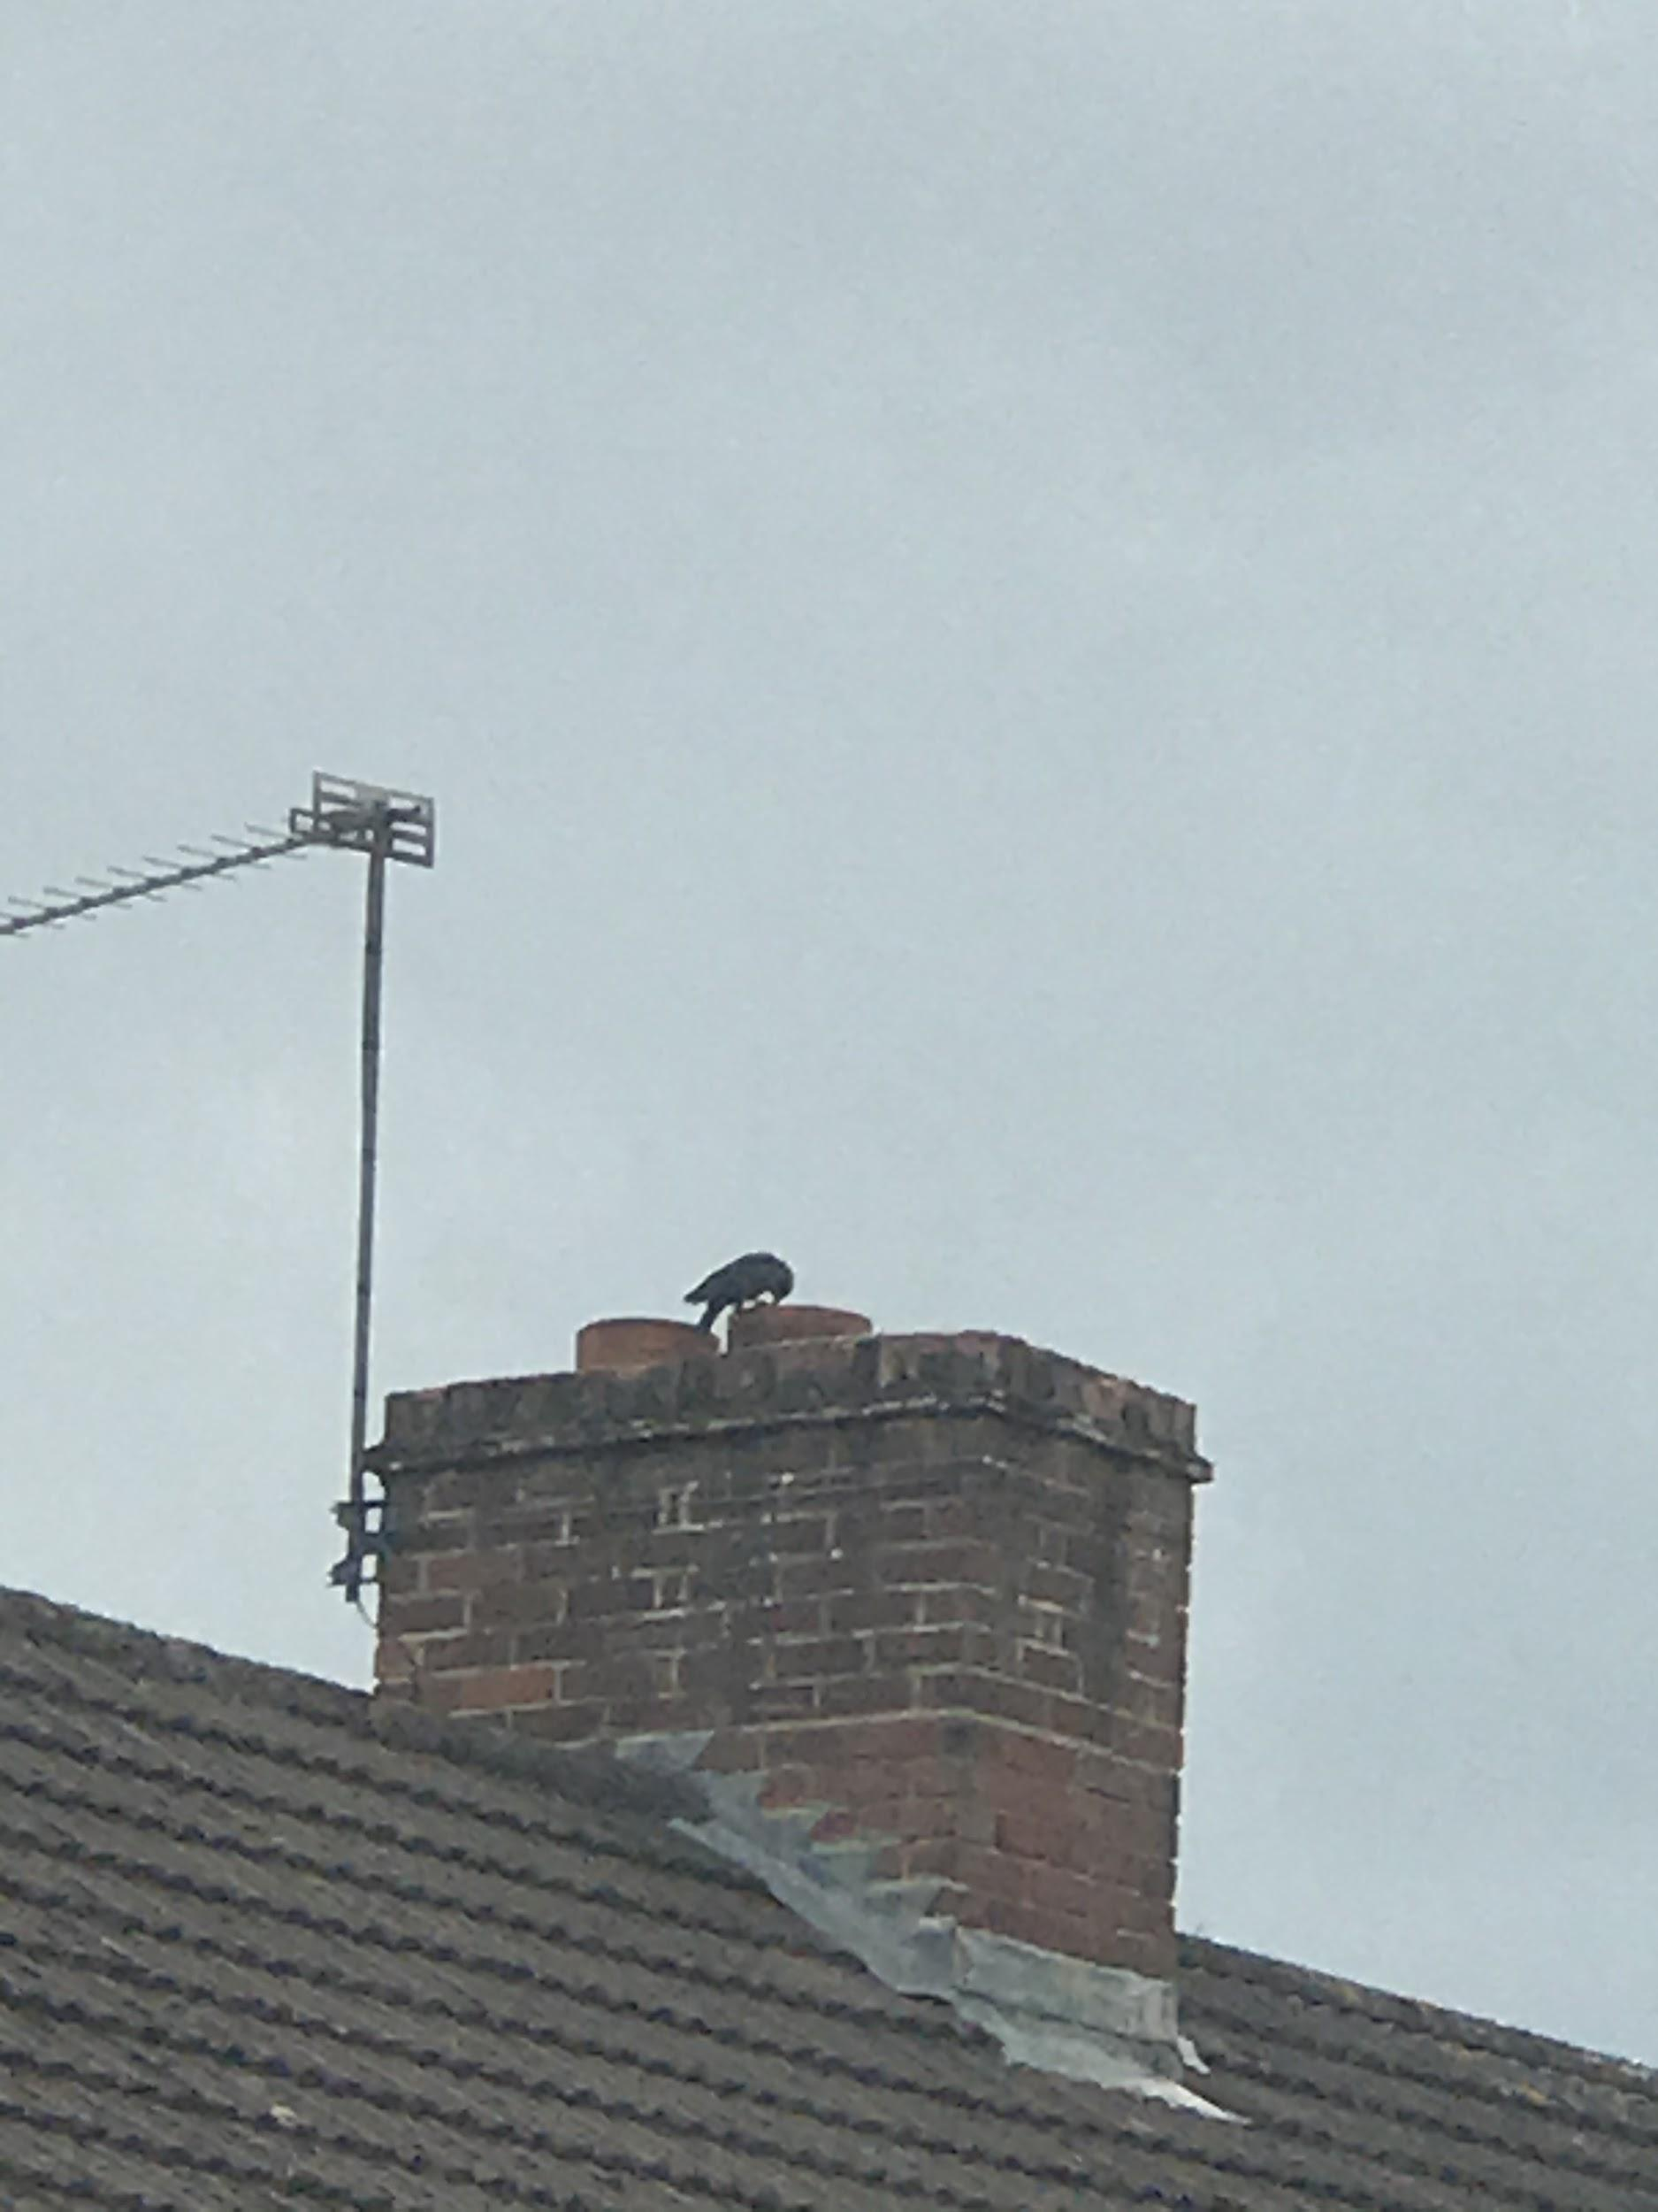
- A healthy adult Jackdaws mass is 250g
- Jackdaws breeding season is April-July

I saw this jackdaw nesting in my neighbours chimney.

Red kite
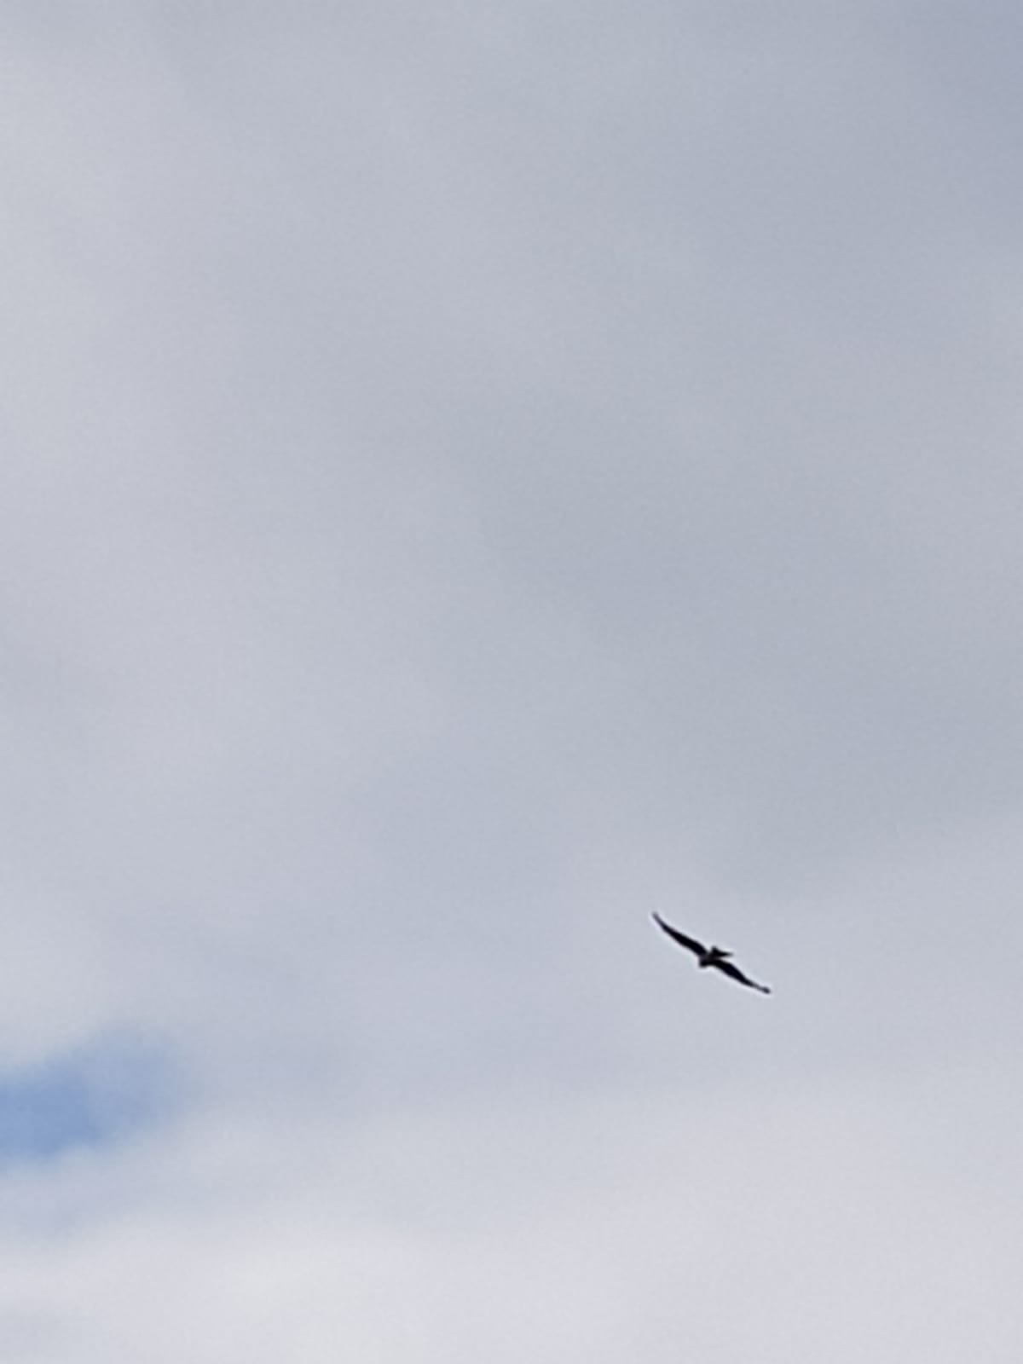
- Red kites mainly eat dead animals because their claws are too weak to kill anything bigger than a small rabbit
- They can fly up to 200km an hour

I found this red kite on one of my walks

Ducks and ducklings
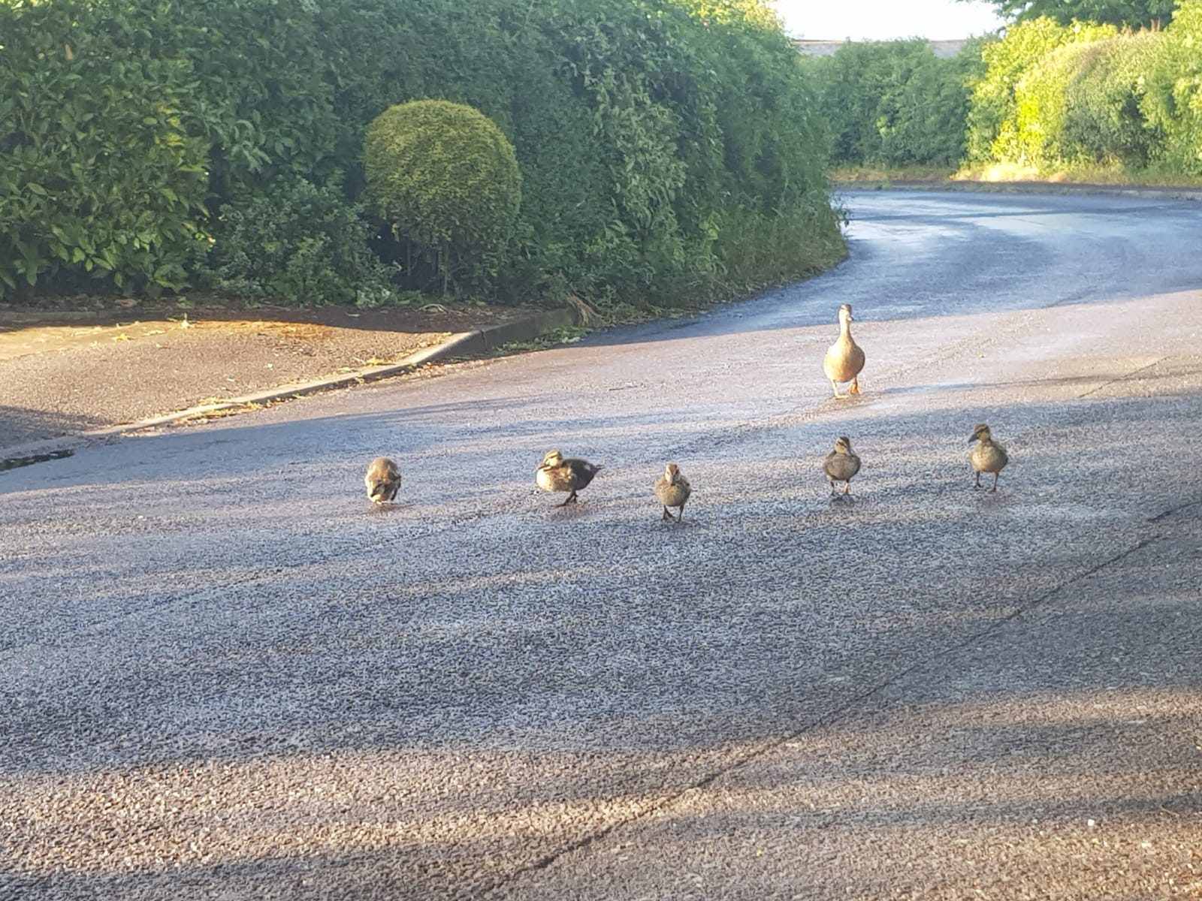
- Ducks eggs are laid between mid-March and the end of July and they normally have about 12 eggs
- Ducks mass is 0.72-1.6kg

I found these ducks on a walk

Pigeon
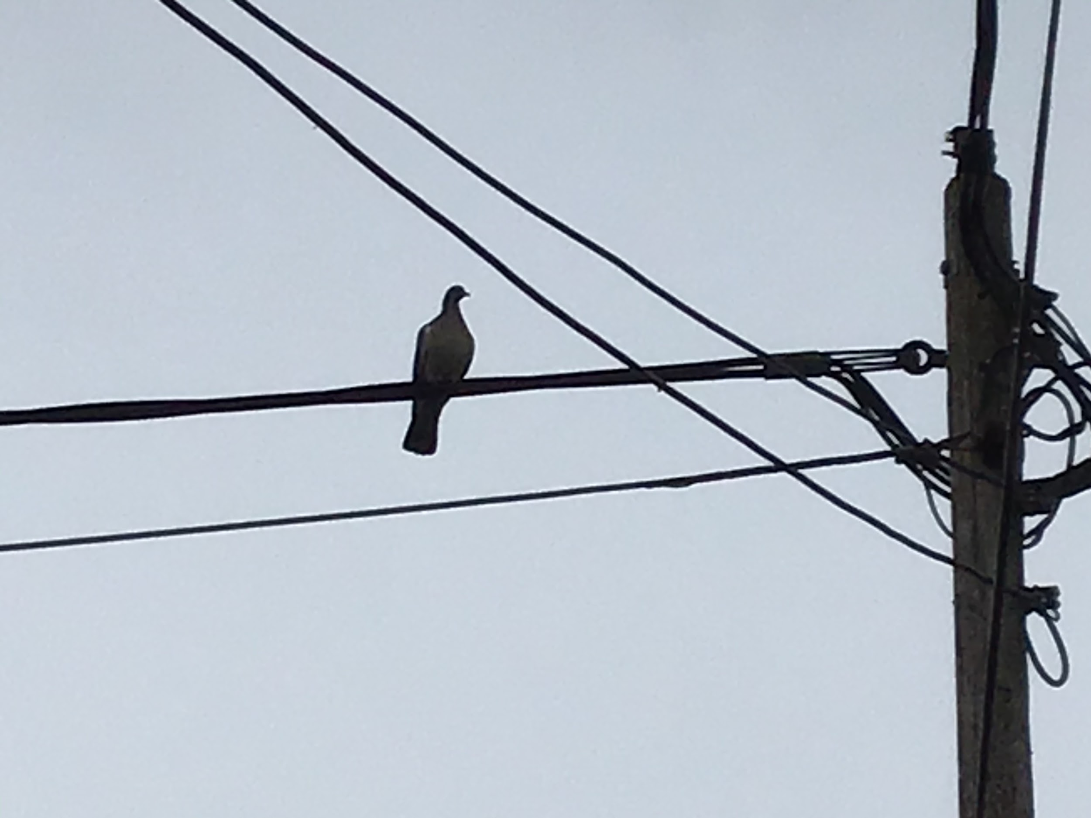
- A pigeon is the most common garden bird
- Their wingspan as an adult is 68-80cm

I found this pigeon chilling on my electricity wire

Swans
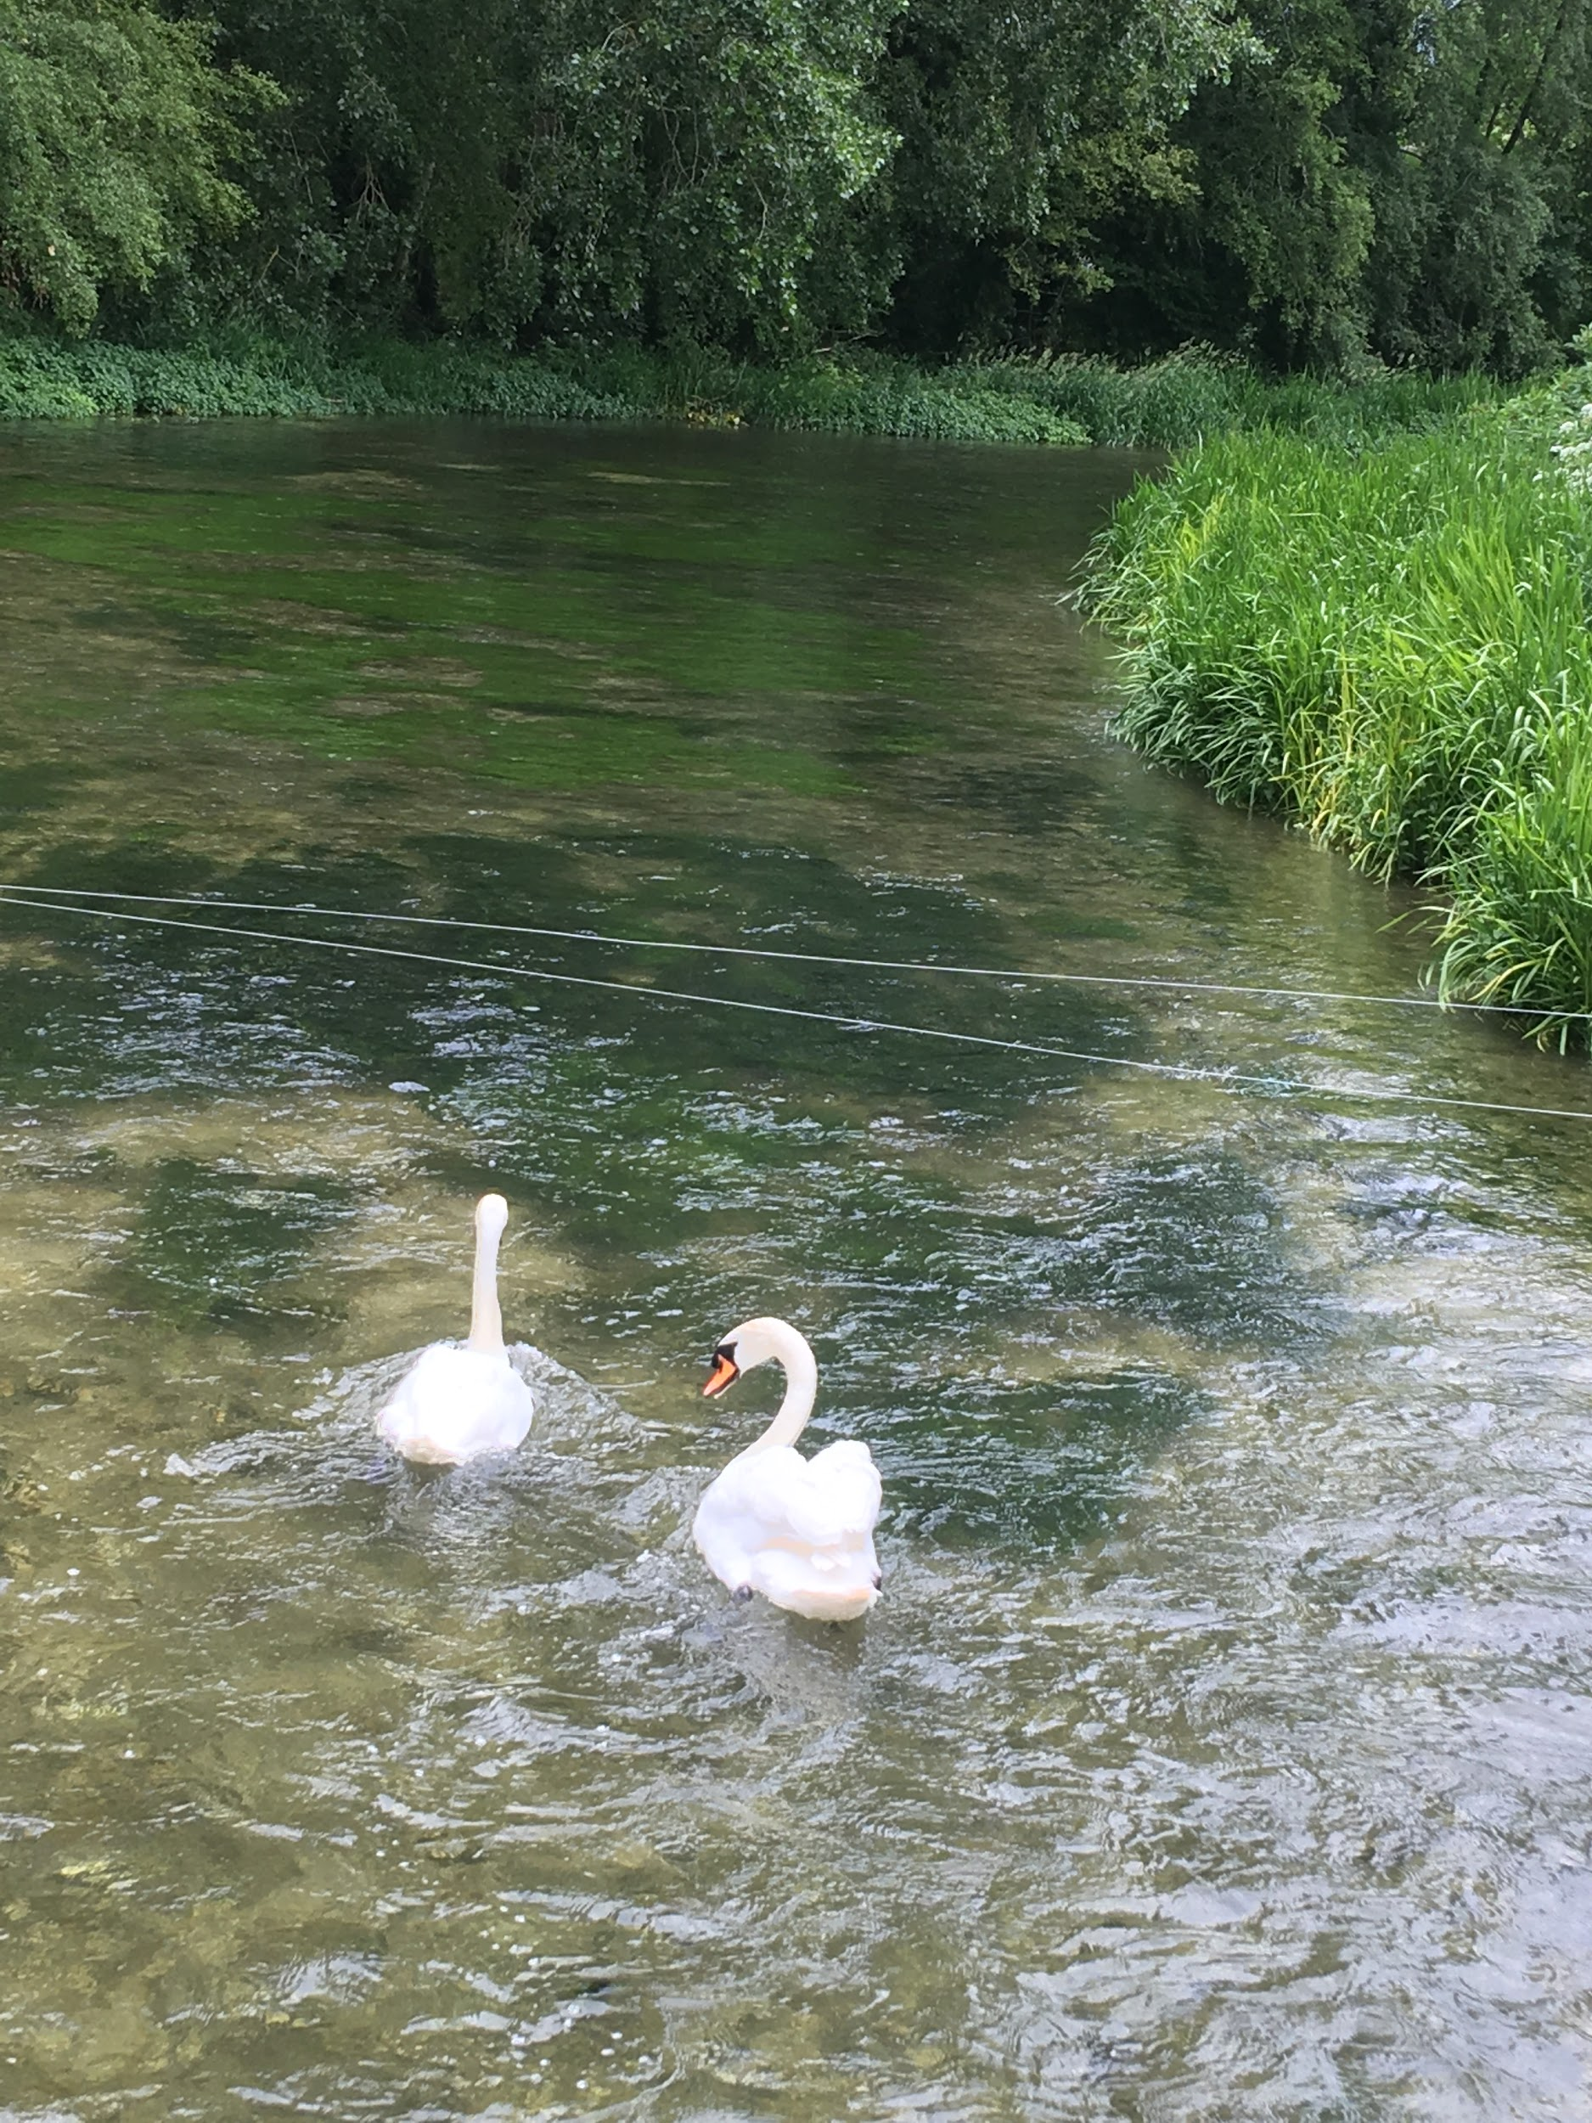

- A swans wingspan is 2-2.4m
- Their mass is 11-12kg

I found these swans at Houghton river

